NAA

Installation and Primary Results of Wavelength Dispersive X-ray Fluorescence Spectrometer at KAERI, Daejeon

Y.H. Nam, G.M. Sun *, M.E. Jin, K.B. Dasari, J.H. Moon, Y.S. Chung

aNeutron Application Research Division, Korea Atomic Energy Research Institute, Daejeon 305-353, Republic of Korea

*Corresponding author: gmsun@kaeri.re.kr

Neutron Activation Analysis (NAA) is one of two primary methods recognized by the International Metrological Commission (BIPM/CCQM) along with the isotope dilution mass spectrometry (ID-MS), which is held by the Korea Research Institute of Standards and Science (KRISS), and has been used as the most important analytical tools in establishing national standards and developing reference materials. Development of reference materials according to the national industrial development stage requires a complementary and cross-checking analysis with various analysis methods, including two primary methods, and in particular, wavelength-dispersive X-ray fluorescence spectrometer (WD-XRF) is one of the most important analytical methods for expanding certified elements in reference materials. Thus, WD-XRF machine was deployed to supplement elements that are difficult to analyze with NAA and to use it as cross-checking tool. We installed a Bruker S8Tiger WD-XRF machine which has excellent analytical sensitivity. It is a sequential type for qualitative, quantitative, and "standardless" multi elemental analysis technique. It has an ability to detect the all most all elements in periodic table down from Be to Am in various matrices samples. The maximum voltage and current of X-ray in the beam tube are 60 kV and 170 mA with high stability of the tube (±0.00006 %). It has many advantages over Energy dispersive XRF in terms of lower detection limits, resolution, sensitivity and various matrices. The sequential WDXRF spectrometer consists of moving detectors mounted on the goniometer are proportional counter efficiently measure light elements from Be to Cu (0.1 keV ~ 8 keV) and scintillation counter efficiently measure modern and heavy elements from Sc to U (> 4 kev), 9 primary X-ray beam filters, 4 collimators, 8 analyzer crystals. The intensities are measured from the different wavelength one after the other. WDXRF machine and bead machine for fusion glass bead are shown in Figure. A bead machine from KATANAX was also installed to prepare the sample. The X-ray spectrometer was calibrated with standards prepared from pure oxides and the results compared to values determined by alternative techniques and calculated values. We are preparation in house standards in various matrices for high precession results. We are planning to standard the method and will be used in reference materials development.

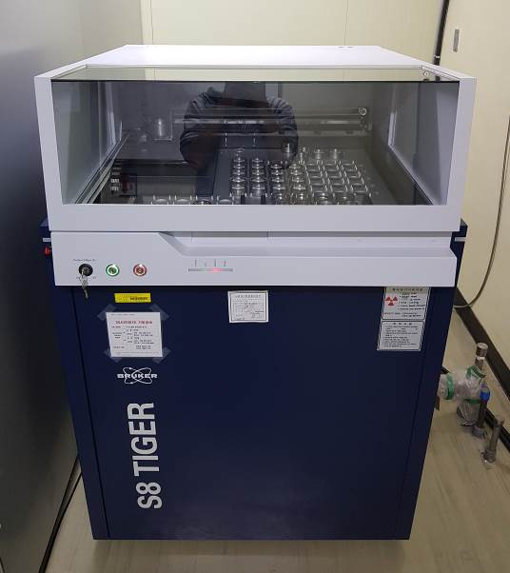 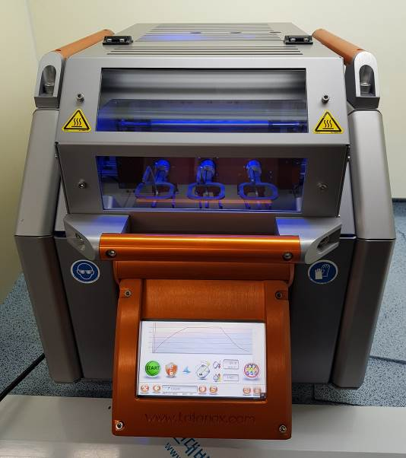

Fig. 1. (Left) Bruker S8Tiger WD-XRF machine, (Right) KATANAX bead machine

**References**

1. A. Van Veen et al., Development of an intense positron beam research facility (POSH) at the HOR, IAEA-SM-360/15 (2000)
2. C. Hugenschmidt et al., High intense positron beam at the new Munich research reactor FRM-II, Applied Surface Science 149 (1999) 7-10